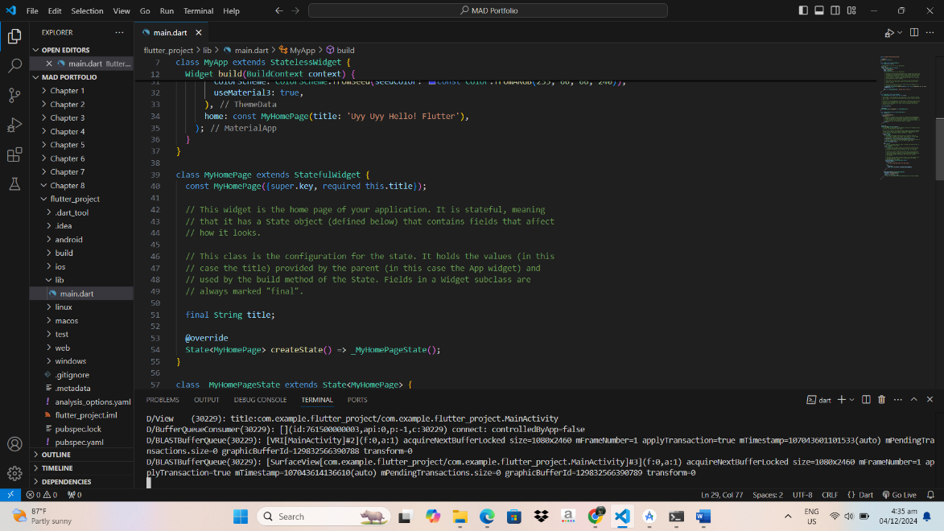Done setting up android emulator. I used my own mobile phone as emulator and to test the code.

I also tried to change the title and it works. From (title: 'Flutter Demo Home Page') to (title: 'Uyy Uyy Hello! Flutter')

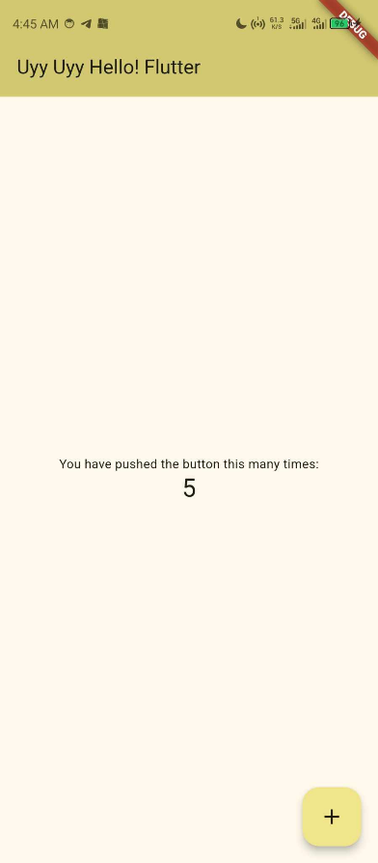

From:

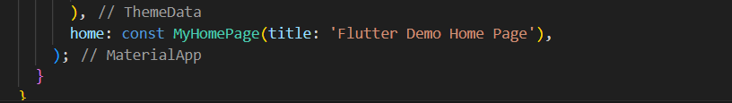

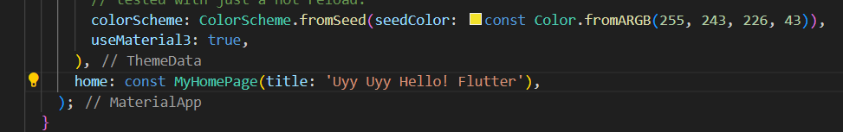To: